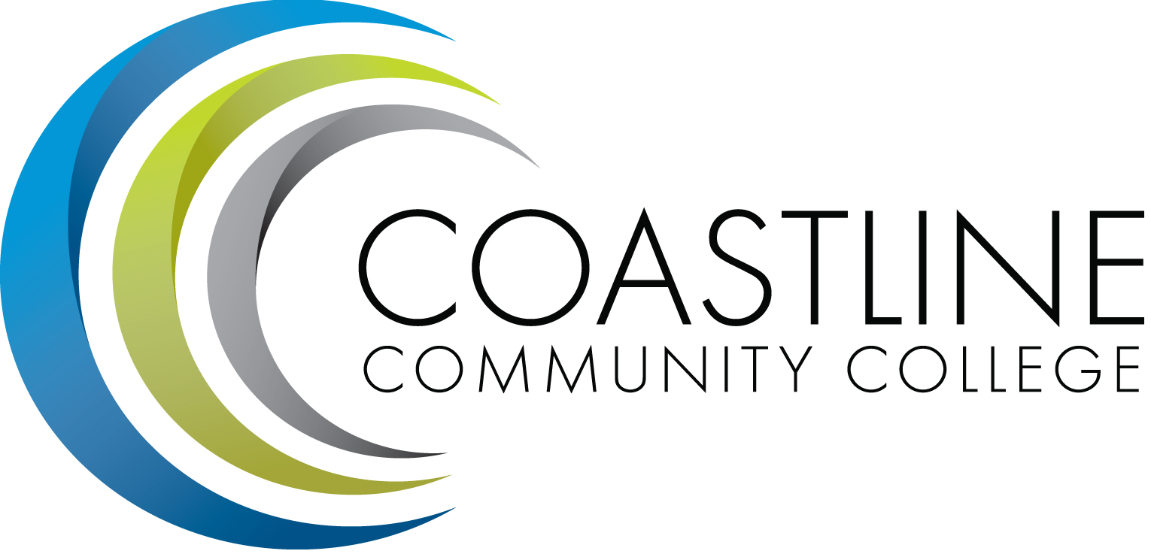
Coastline Management Meeting (CMT) Agenda
August 7, 2018, 9:00 – 11:00 a.m.
College Center – 4th Floor Conference Room

Committee Mandate: To review and improve College operations and management through sharing information, discussion, and staff development.

CALL TO ORDER
  - Welcome
1.1.1 New Members
  - Adoption of Agenda
  - *Approval of Minutes – June 5, 2018

REPORTS & UPDATES
  - Executive Team Update (Groot, Mueller, Nguyen, Rodriguez)
  - ASG (N. Brais)
  - Academic Senate (A. Holliday)
  - Classified Senate (R. Triggs)
  - Research Minute (A. Zentner)
  - *Website Update (D. Willson)

CLOSING THE LOOP – FOLLOW UP ACTIONS

PLANNING/DISCUSSION
- AP 7400 – Travel (C. Nguyen)
- Intranet (D. Willson)
- Professional Development – DISC (S. Blair)

- PROFESSIONAL DEVELOPMENT
  - Future Items – Data Cubes, Civitas
- ANNOUNCEMENTS
  - Guided Pathways (S. Blair)
  - Accessibility Academy (B. Nash)

- CLOSED SESSION/CDMA
  - Jhana Website (R. Akins)

- ADJOURNMENT
*Attachment
Next Meeting: September 4, 2018, College Center

